Color Palette 1

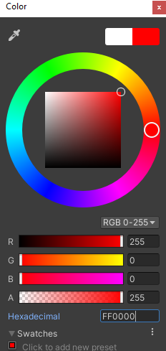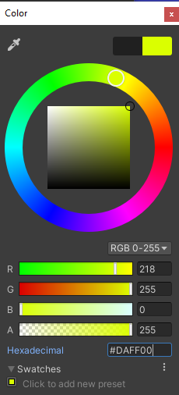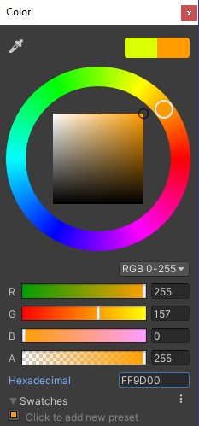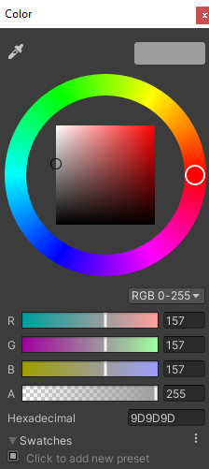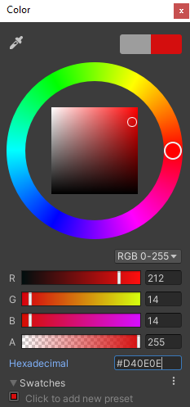

The idea behind this palette is a more volcanic environment, these colors being used to portray the heat of the volcano as well as the dead-feeling the ashes create. Each color was chosen for either their heat (red colors) or their less life-like feel (Grey)

Color Palette 2

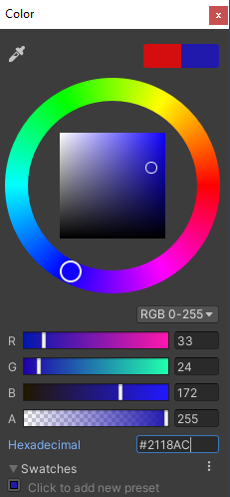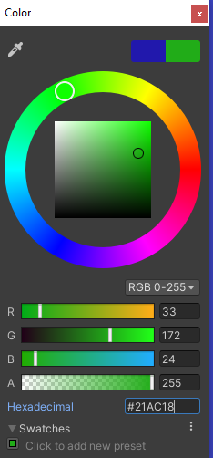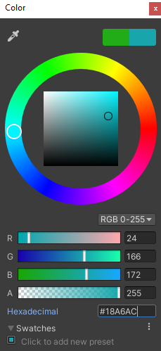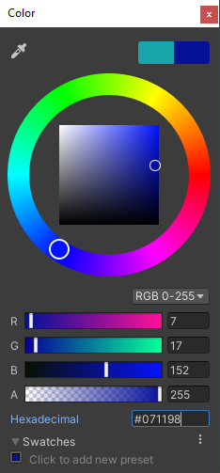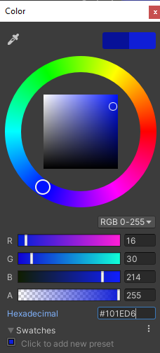

This color palette would be used for a more ocean-like setting. Each blue is for the varying contrasting colors of the water, usually dependent on how deep or the temperature the water is. The Green would be used for the plant life down there, such as seaweed. Each color has a deeper shade, as the ocean is quite dark deep down.

Color Palette 3

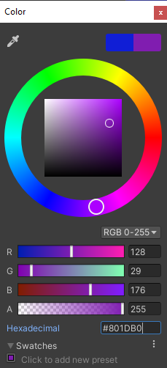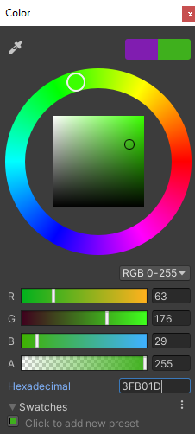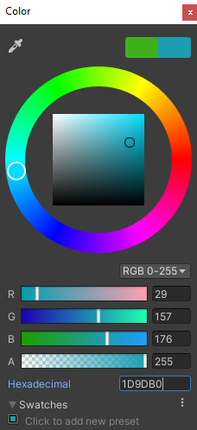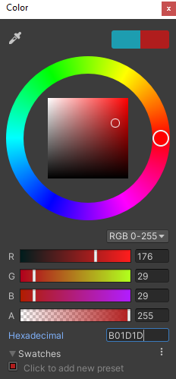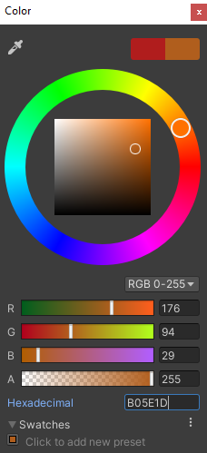

To be fully honest I didn’t think of an amazing idea for what these colors could be used for, however I believe they mesh well together, and would fit maybe a certain building setting? Possibly even a wizard with different colors being used for each spell. They were chosen because of how they work together and complement each other.

Color Palette 4

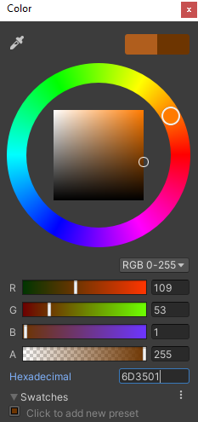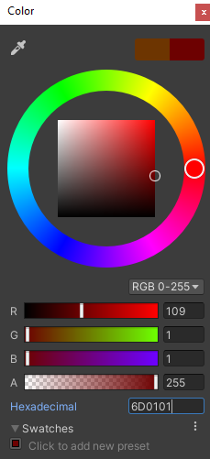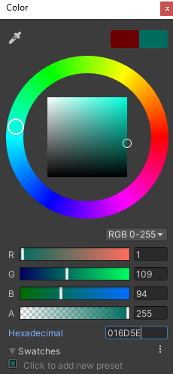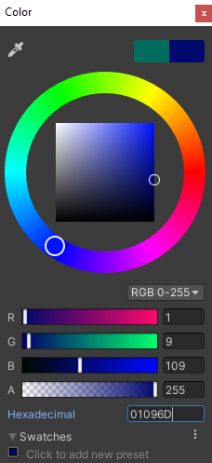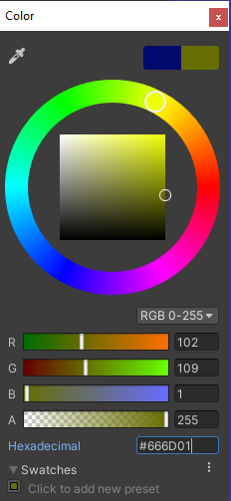

This palette was chosen for how the dark colors complement each other in their use. I believe this could be used for maybe the ruins of a building that has fallen from grace. The muted and dark tones of each of the colors could be examples of how bright the place used to be before tragedy.

Color Palette 5

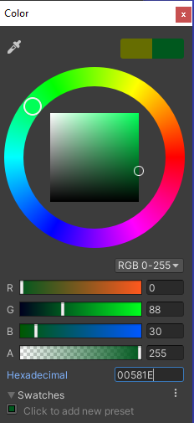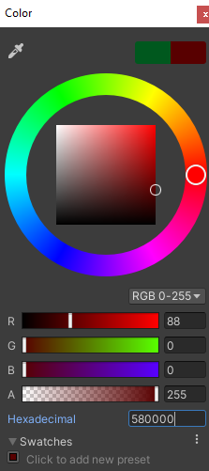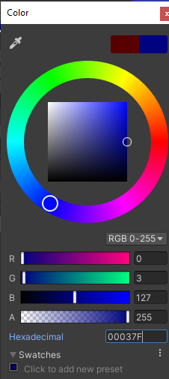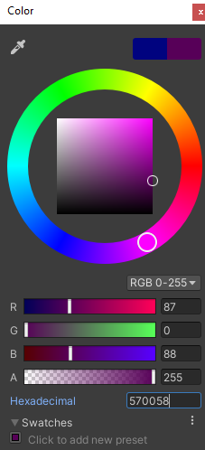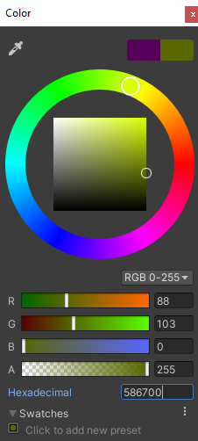

These colors were picked for similar reasons, being that they fit well and are muted and darker versions of usually more vibrant colors. These would work pretty well in a horror setting, as well as just a setting that likes darker colors. They fit well as their actual values are very similar, just with a different main color each time.